**NO GATING**

**Low**

**NO GATING –– homogeneous damping –– I = 0.1 (low) –– ER4 –– seed92391**

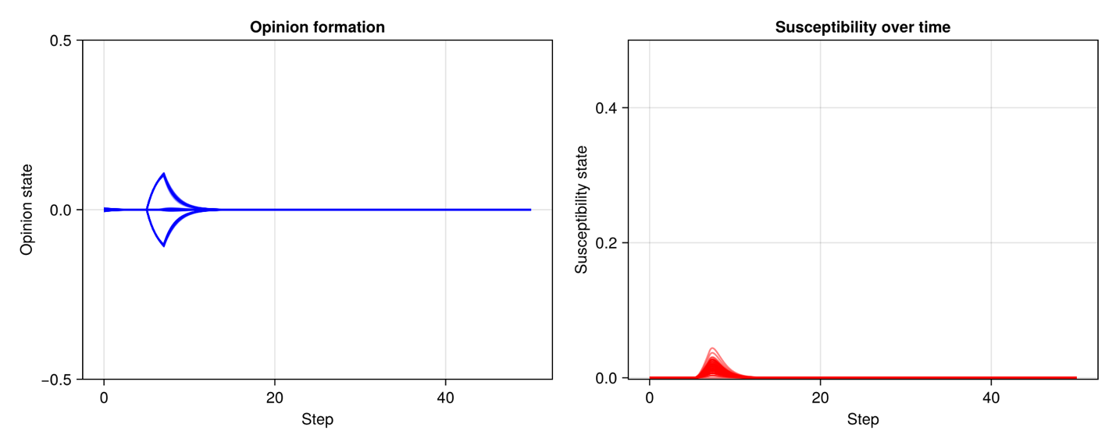

**NO GATING –– homogeneous damping –– I = 0.1 (low) –– BA3 –– seed92391**

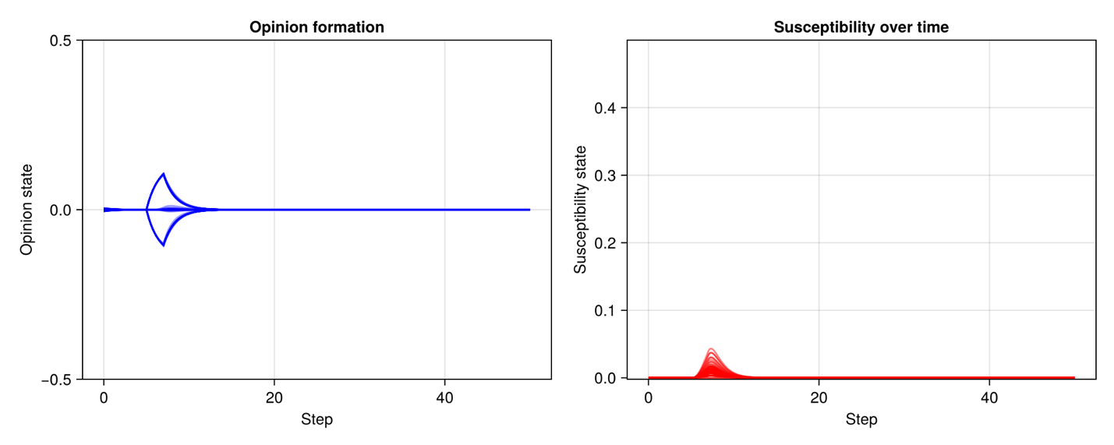

**NO GATING –– homogeneous damping –– I = 0.1 (low) –– WS4 –– seed92391**

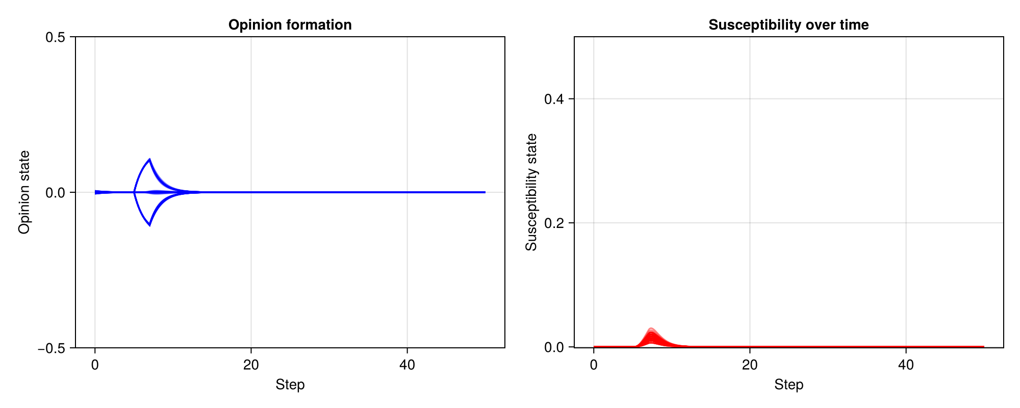

**Medium**

***Erdos-Renyi***

**NO GATING –– homogeneous damping –– I = 0.25 (medium) –– ER4 –– seed92391**

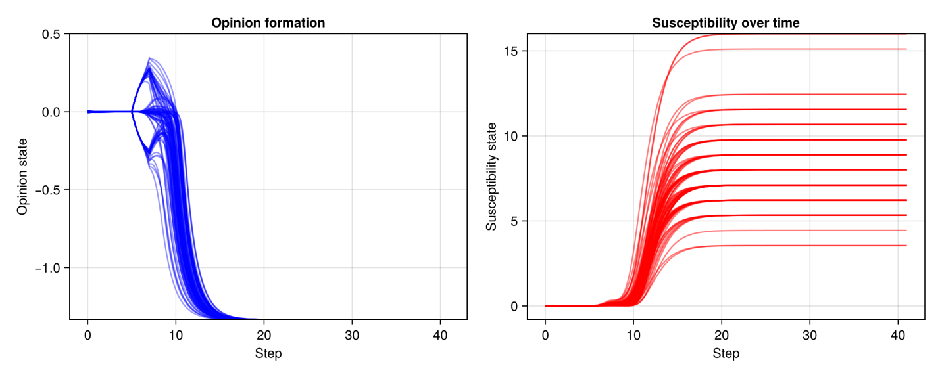

**NO GATING –– homogeneous damping –– I = 0.25 (medium) –– ER4 –– seed2854**

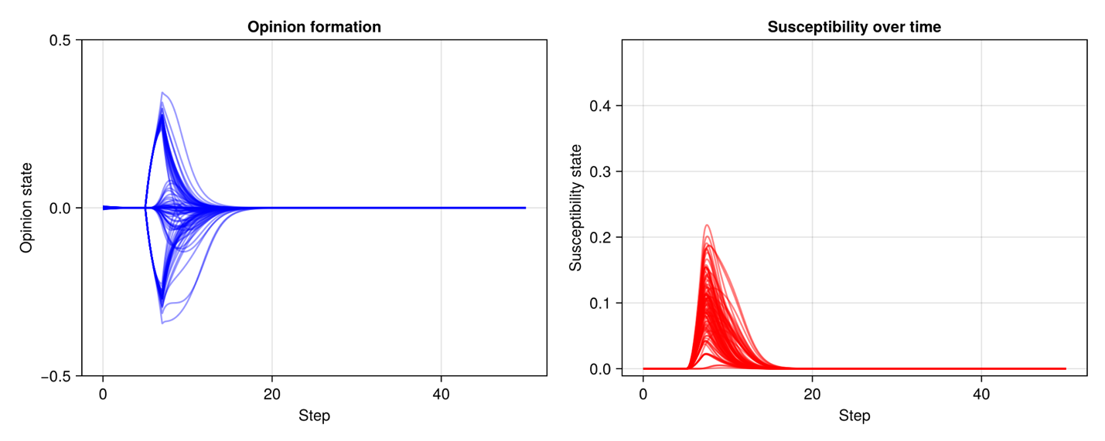

**NO GATING –– homogeneous damping –– I = 0.25 (medium) –– ER5 –– seed2854**

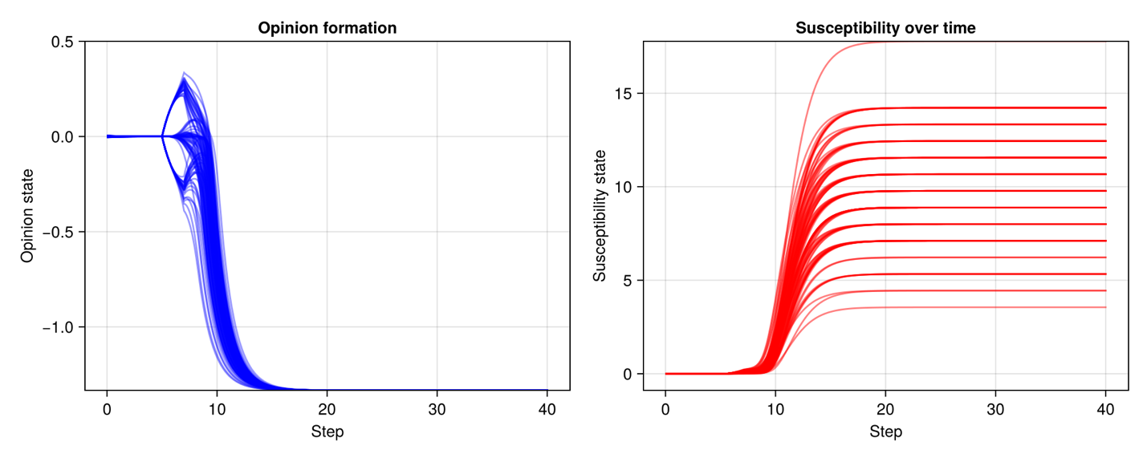

***Scale-free (Barabasi-Albert)***

**NO GATING –– homogeneous damping –– I = 0.25 (medium) –– BA3 –– seed92391**

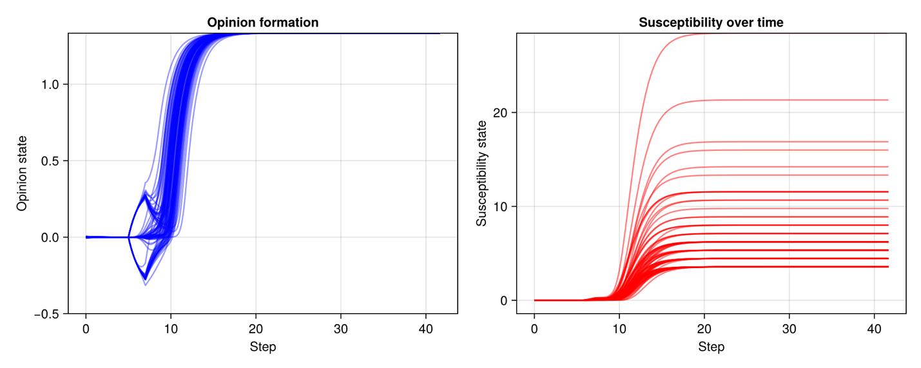

**NO GATING –– homogeneous damping –– I = 0.25 (medium) –– BA3 –– seed2854**

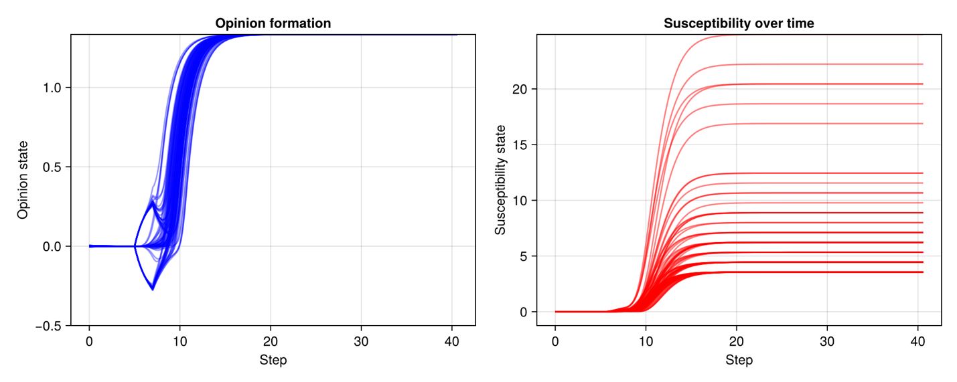

**NO GATING –– homogeneous damping –– I = 0.25 (medium) –– BA4 –– seed2854**

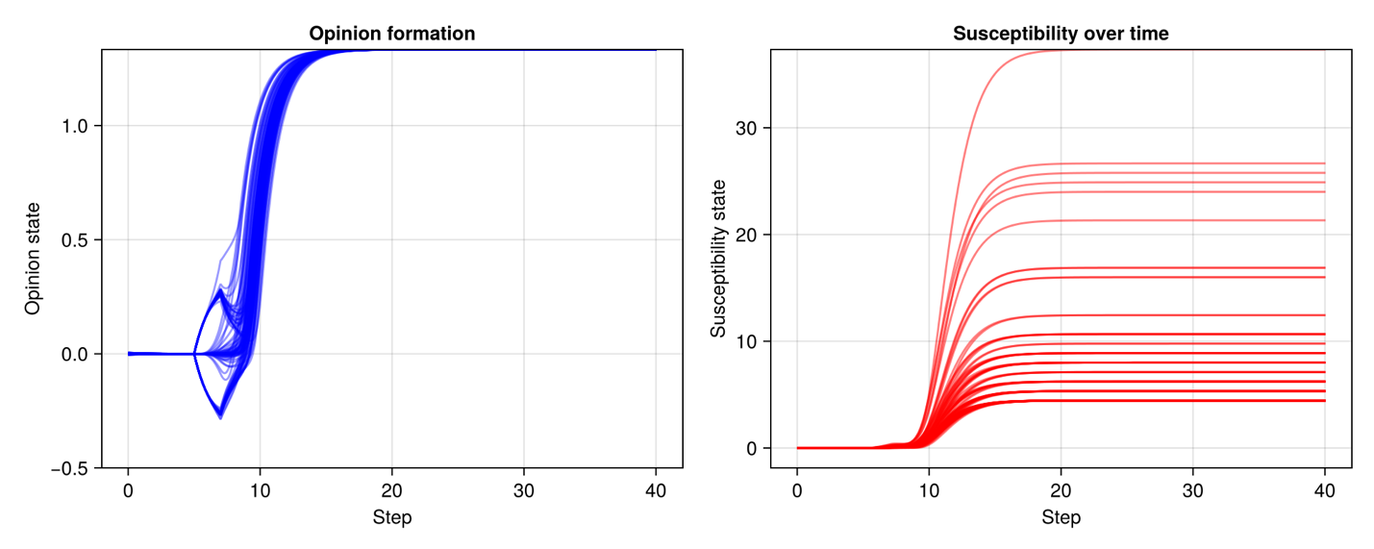

***Small-world/with clusters (Watts-Strogatz)***

**NO GATING –– homogeneous damping –– I = 0.25 (medium) –– WS4 –– seed92391**

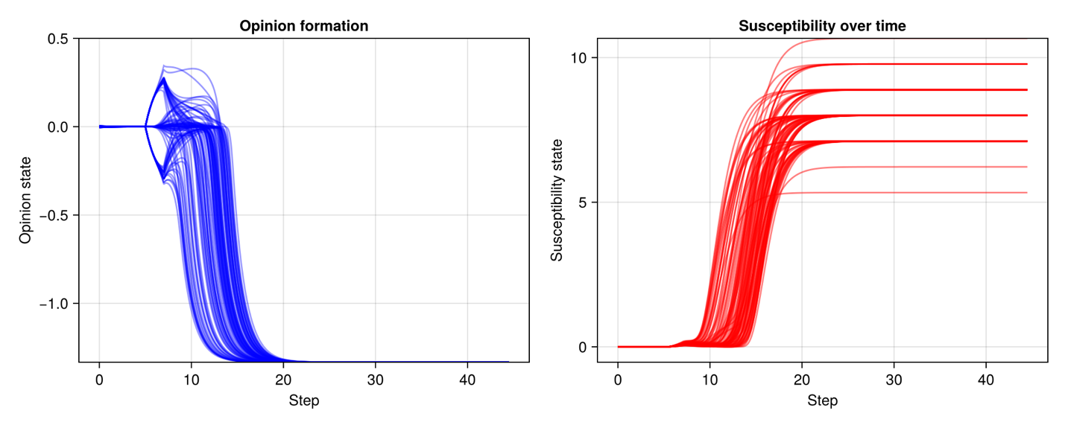

**NO GATING –– homogeneous damping –– I = 0.25 (medium) –– WS4 –– seed2854**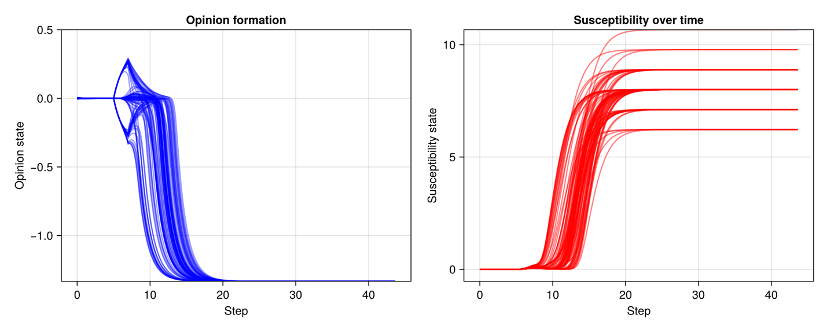

**NO GATING –– homogeneous damping –– I = 0.25 (medium) –– WS5 –– seed2854**

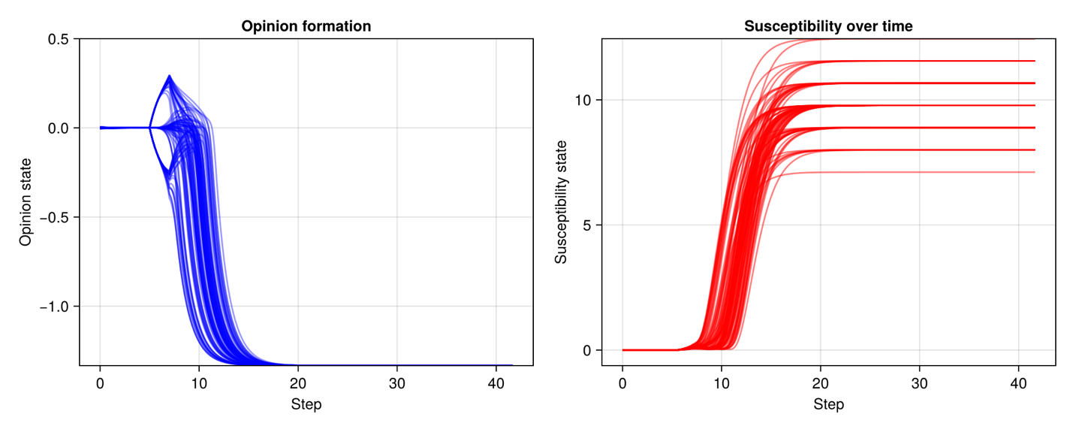

**High**

***Erdos-Renyi***

**NO GATING –– homogeneous damping –– I = 0.4 (high) –– ER4 –– seed92391**

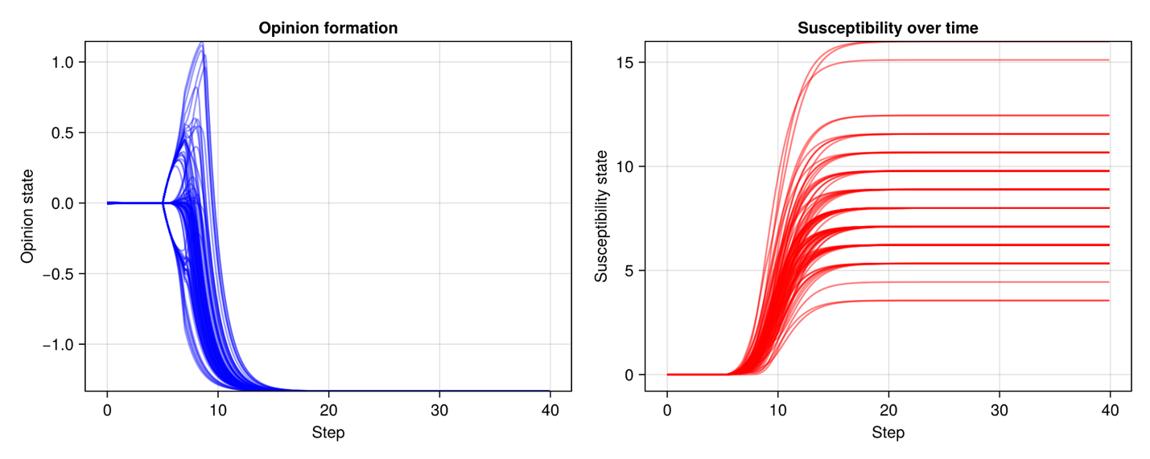

**NO GATING –– homogeneous damping –– I = 0.4 (high) –– ER4 –– seed2854**

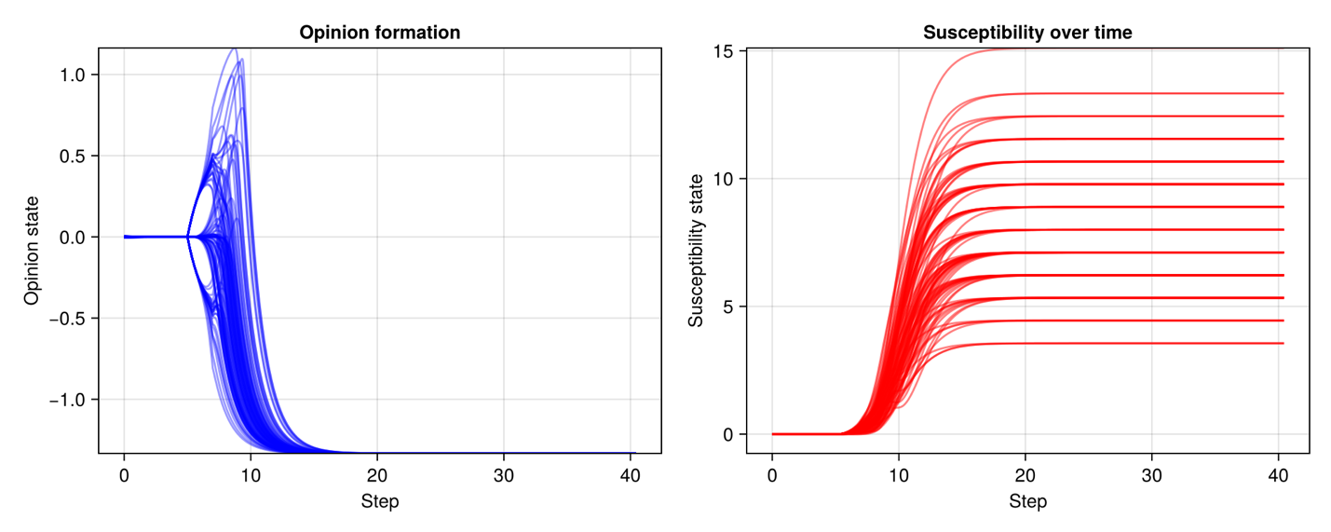

**NO GATING –– homogeneous damping –– I = 0.4 (high) –– ER5 –– seed2854**

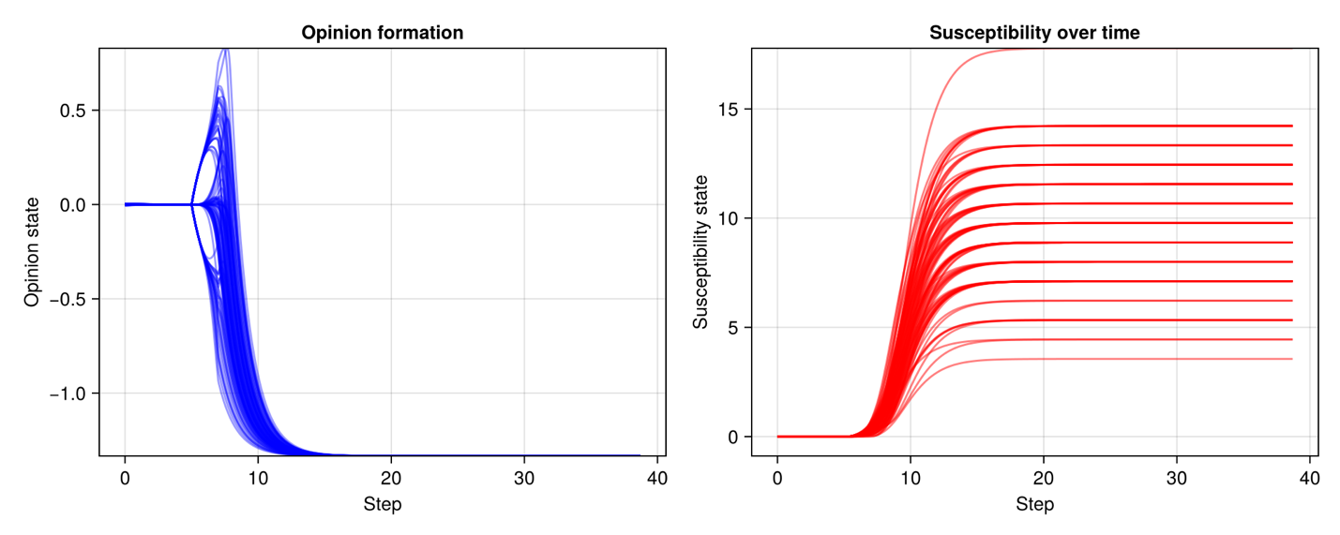

***Scale-free (Barabasi-Albert)***

**NO GATING –– homogeneous damping –– I = 0.4 (high) –– BA3 –– seed92391**

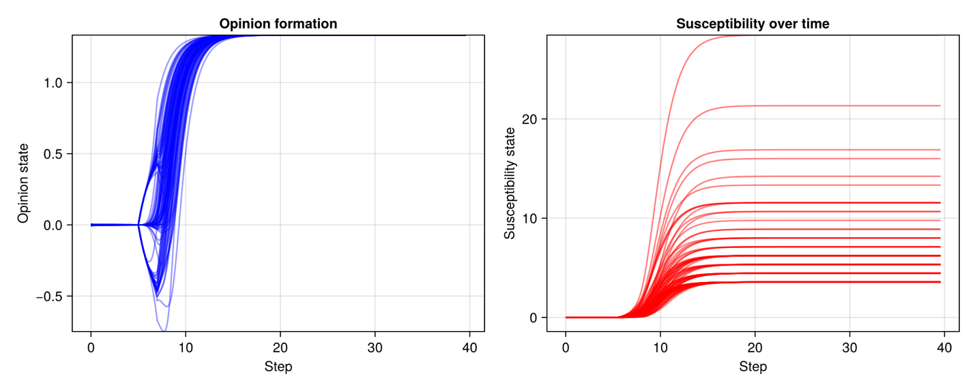

**NO GATING –– homogeneous damping –– I = 0.4 (high) –– BA4 –– seed2854**

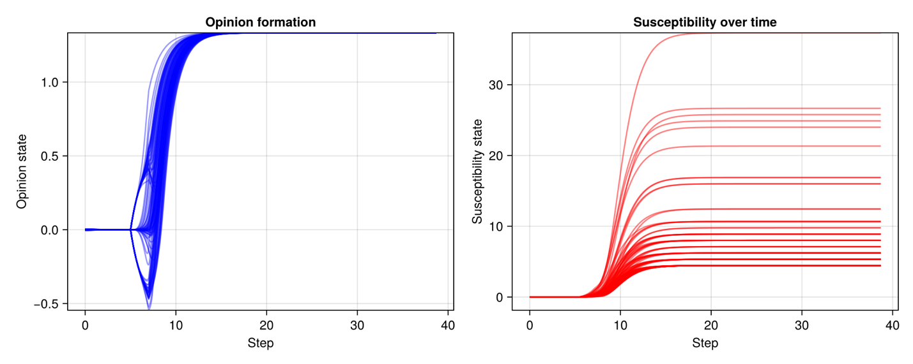

***Small-world/with clusters (Watts-Strogatz)***

**NO GATING –– homogeneous damping –– I = 0.4 (high) –– WS4 –– seed92391**

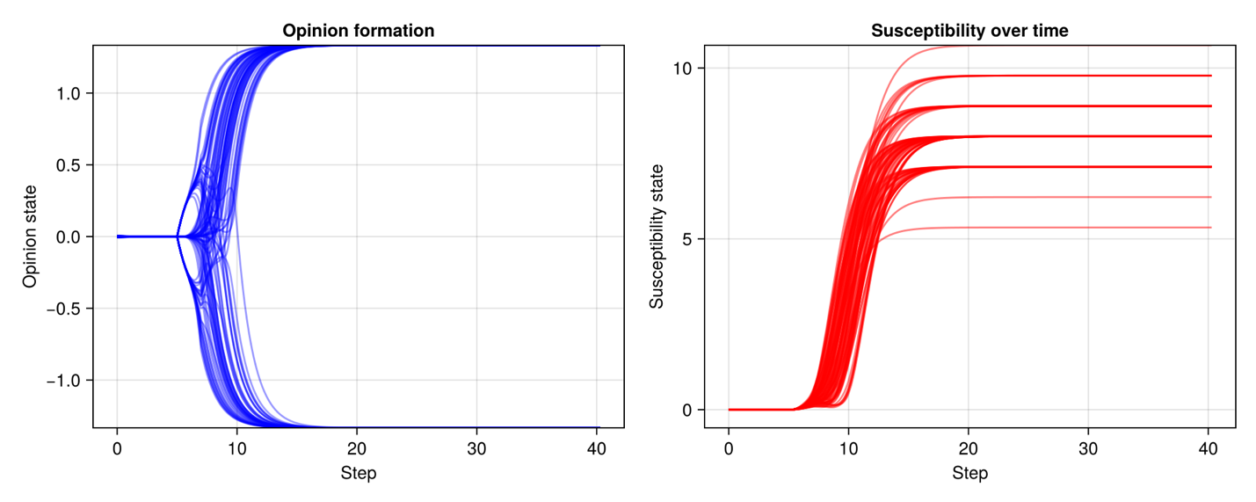

**NO GATING –– homogeneous damping –– I = 0.4 (high) –– WS4 –– seed2854**

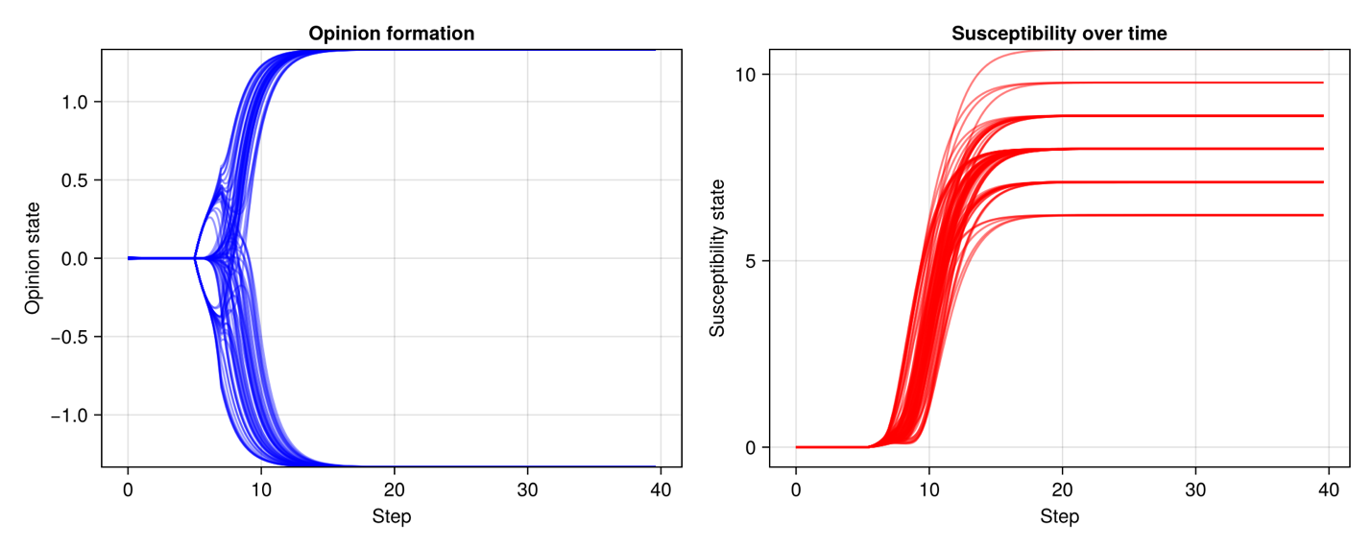

**NO GATING –– homogeneous damping –– I = 0.4 (high) –– WS5 –– seed2854**

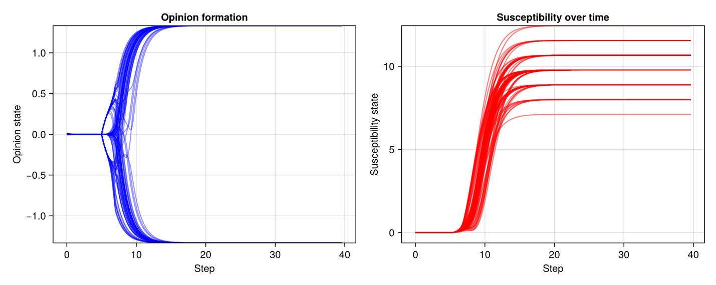

**GATING**

**Low**

**WITH GATING –– homogeneous damping –– I = 0.1 (low) –– ER4 –– seed92391**

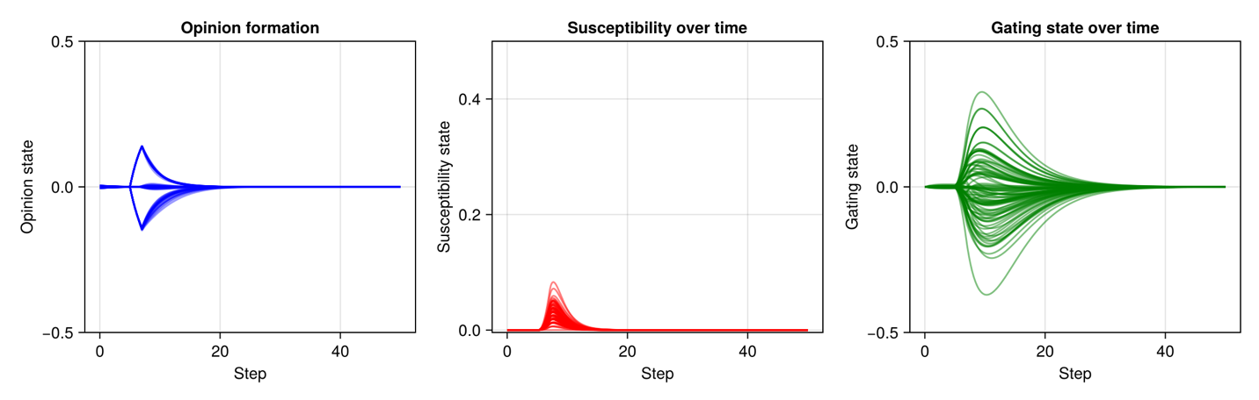

**WITH GATING –– homogeneous damping –– I = 0.1 (low) –– BA3 –– seed92391**

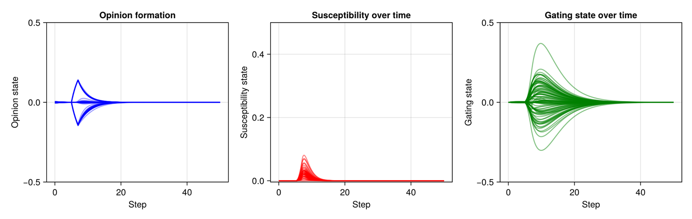

**WITH GATING –– homogeneous damping –– I = 0.1 (low) –– WS4 –– seed92391**

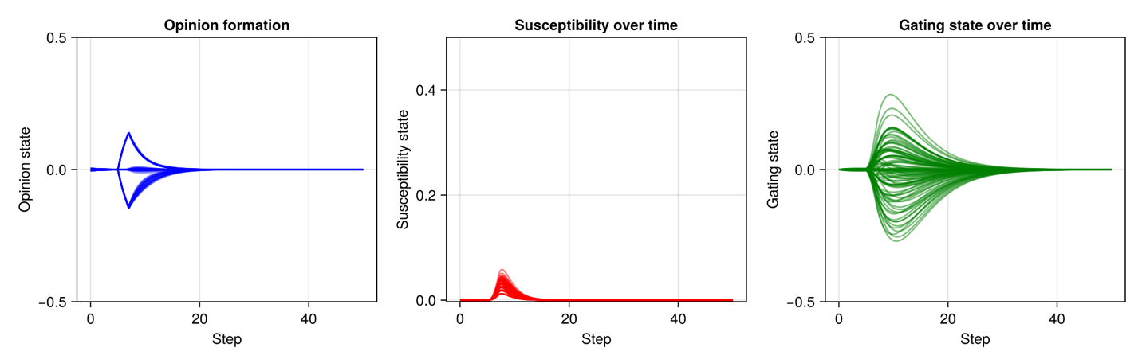

**Medium**

***Erdos-Renyi***

**WITH GATING –– homogeneous damping –– I = 0.25 (medium) –– ER4 –– seed92391**

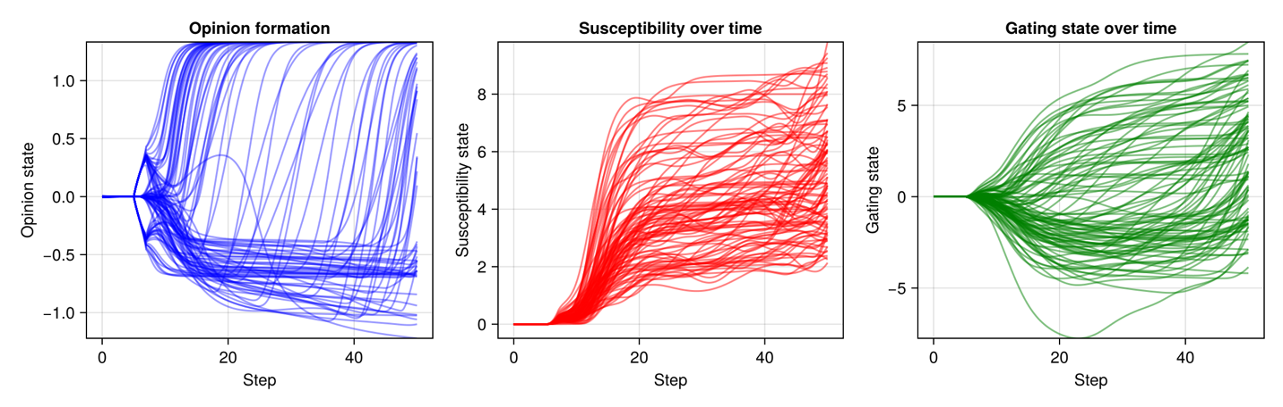

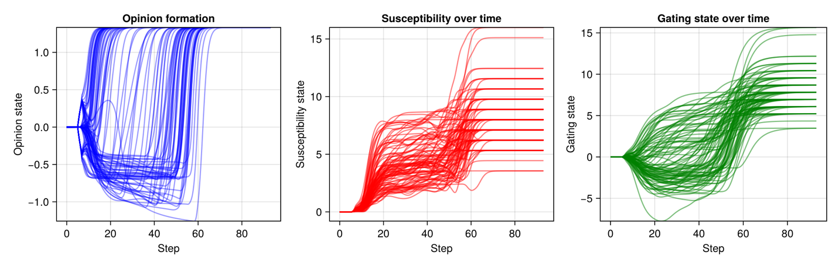

**WITH GATING –– homogeneous damping –– I = 0.25 (medium) –– ER4 –– seed2854**

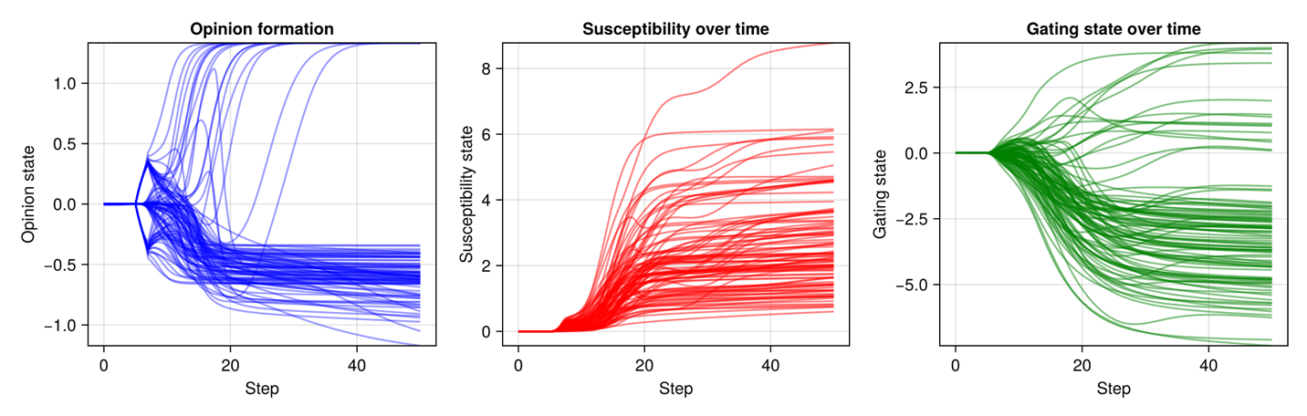

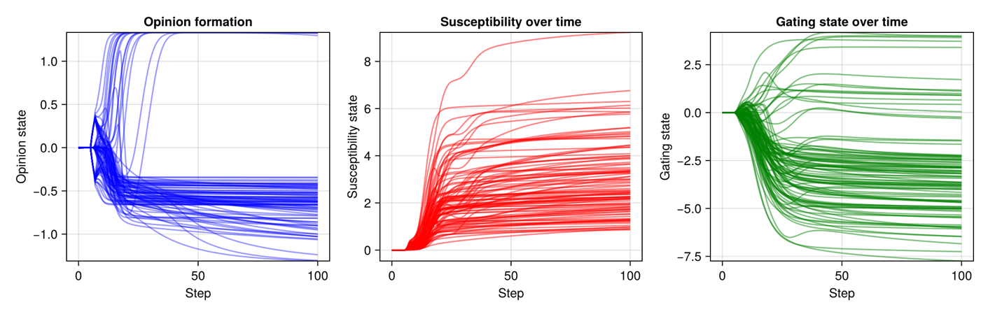

**WITH GATING –– homogeneous damping –– I = 0.25 (medium) –– ER5 –– seed2854**

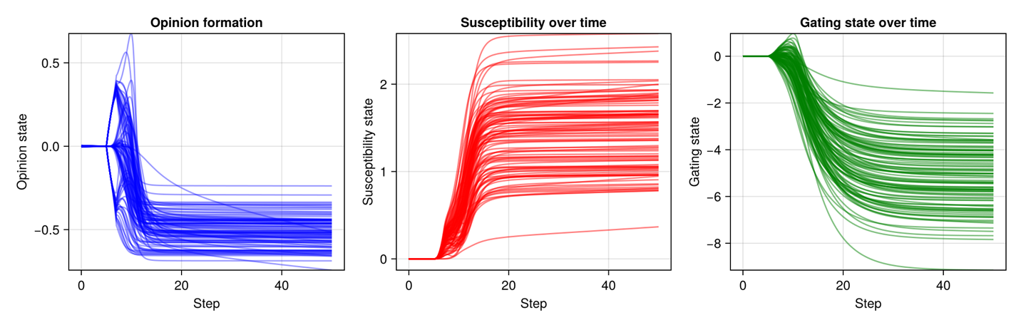

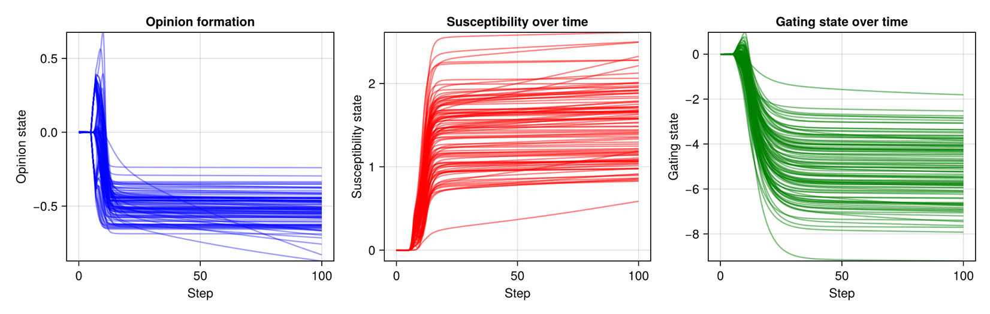

***Scale-free (Barabasi-Albert)***

**WITH GATING –– homogeneous damping –– I = 0.25 (medium) –– BA3 –– seed92391**

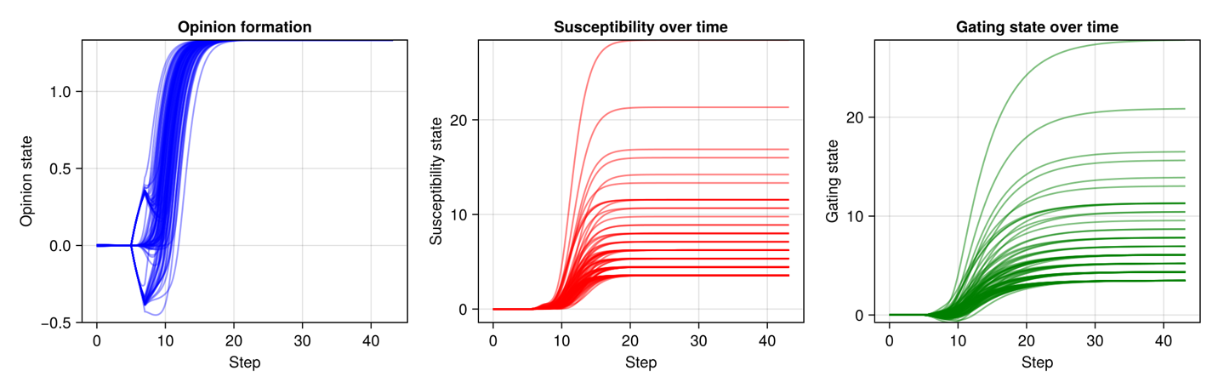

**WITH GATING –– homogeneous damping –– I = 0.25 (medium) –– BA3 –– seed2854**

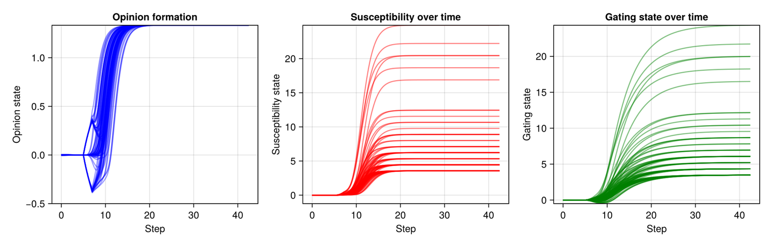

**WITH GATING –– homogeneous damping –– I = 0.25 (medium) –– BA4 –– seed2854**

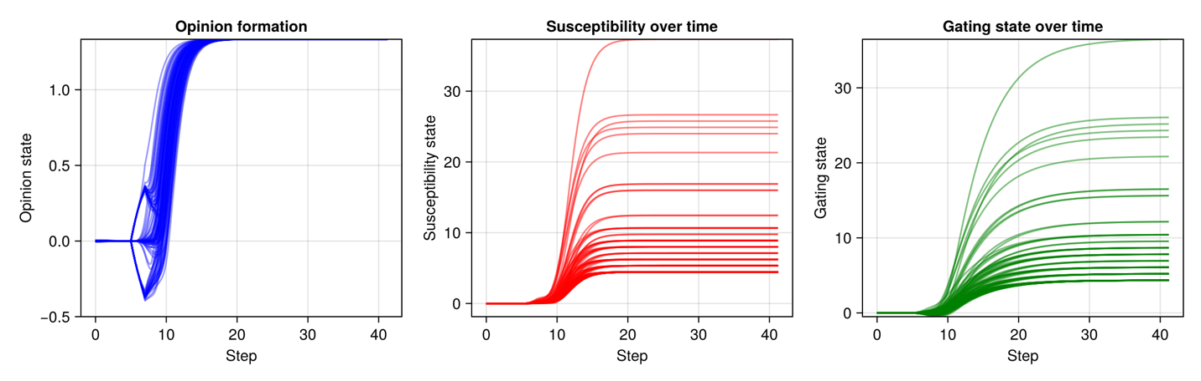

***Small-world/with clusters (Watts-Strogatz)***

**WITH GATING –– homogeneous damping –– I = 0.25 (medium) –– WS4 –– seed92391**

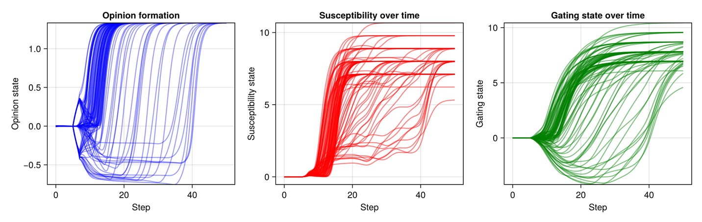

**WITH GATING –– homogeneous damping –– I = 0.25 (medium) –– WS4 –– seed2854**

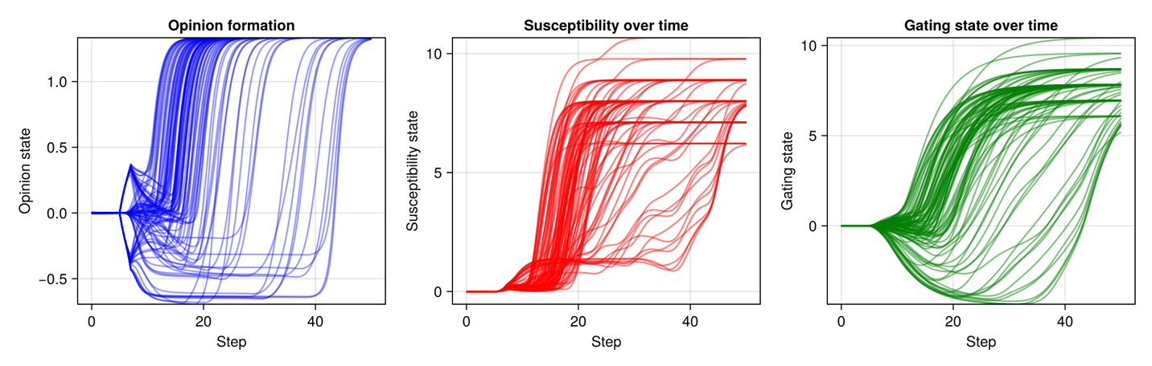

**WS4 – seed 9286 – longer**

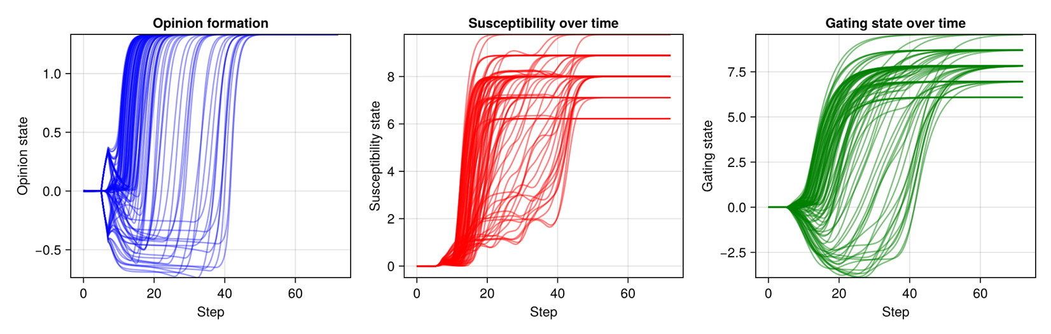

**WITH GATING –– homogeneous damping –– I = 0.25 (medium) –– WS5 –– seed2854**

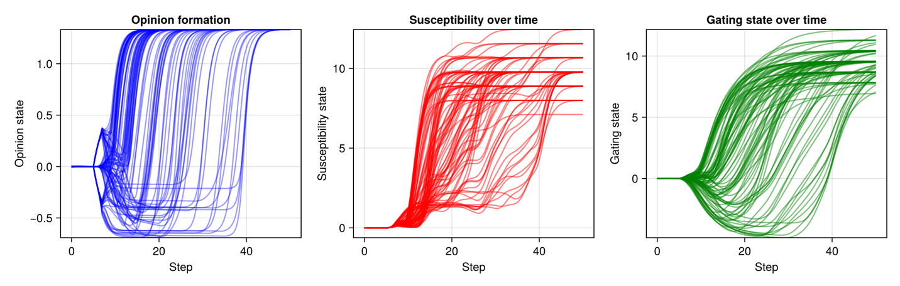

**High**

***Erdos-Renyi***

**WITH GATING –– homogeneous damping –– I = 0.4 (high) –– ER4 –– seed92391**

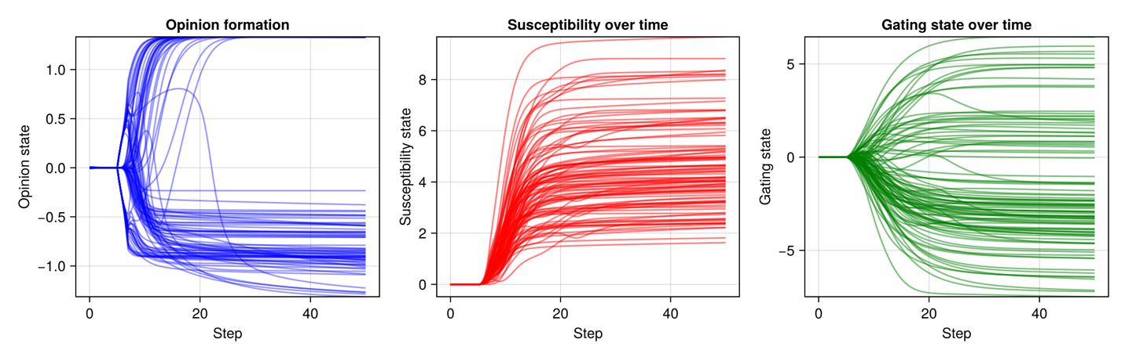

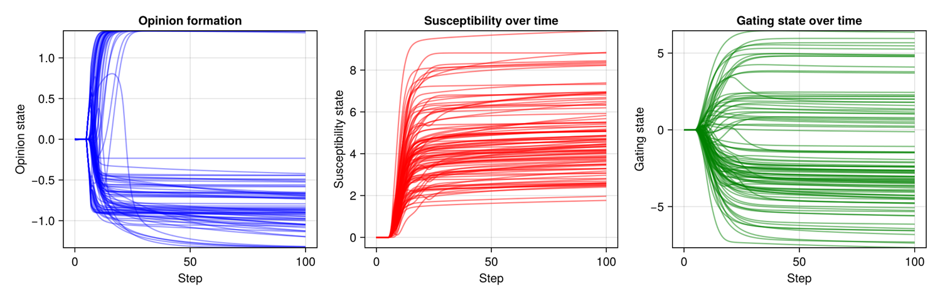

**WITH GATING –– homogeneous damping –– I = 0.4 (high) –– ER4 –– seed2854**

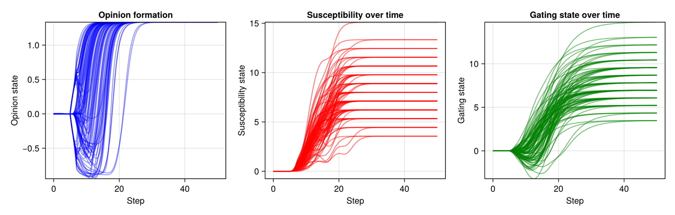

**ER4 – seed 9286 – longer**

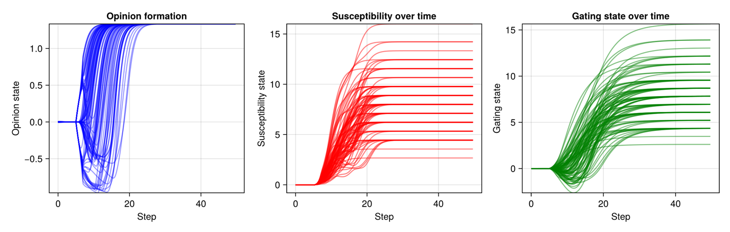

**WITH GATING –– homogeneous damping –– I = 0.4 (high) –– ER5 –– seed2854**

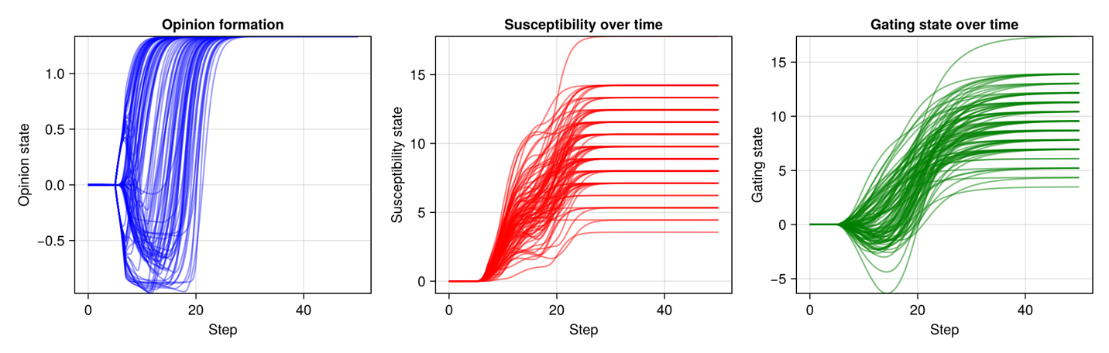

***Scale-free (Barabasi-Albert)***

**WITH GATING –– homogeneous damping –– I = 0.4 (high) –– BA3 –– seed92391**

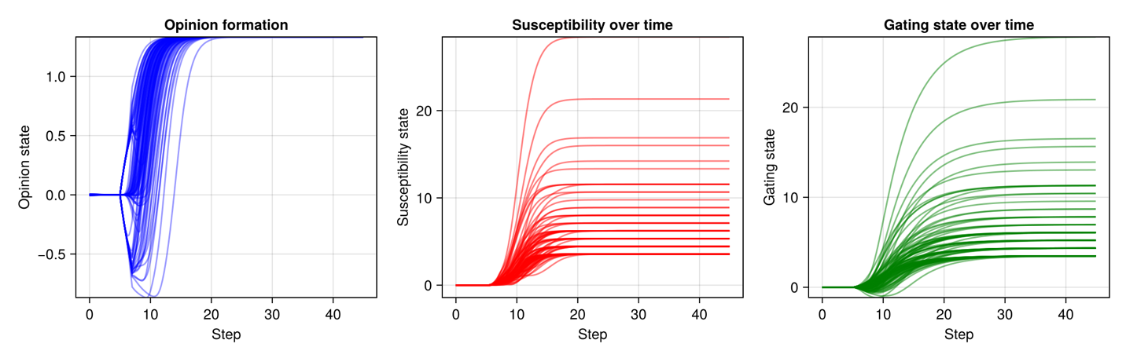

**WITH GATING –– homogeneous damping –– I = 0.4 (high) –– BA4 –– seed2854**

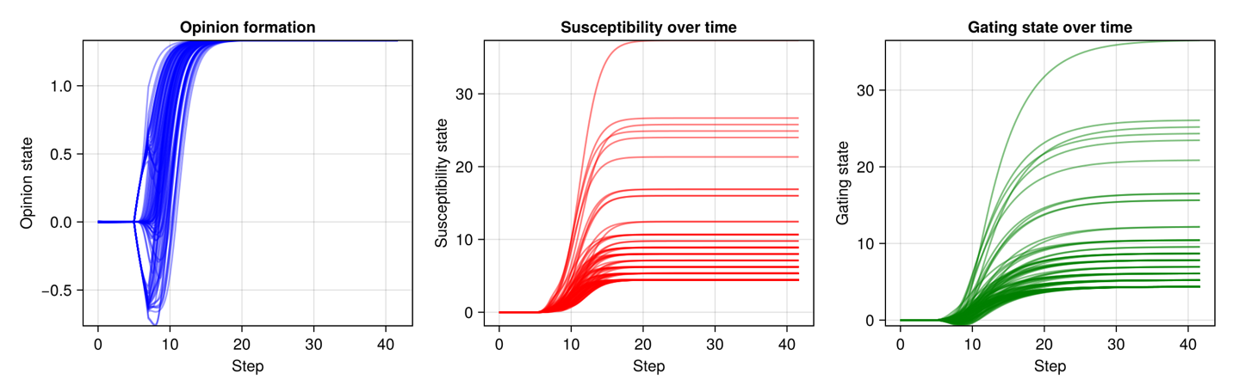

***Small-world/with clusters (Watts-Strogatz)***

**WITH GATING –– homogeneous damping –– I = 0.4 (high) –– WS4 –– seed92391**

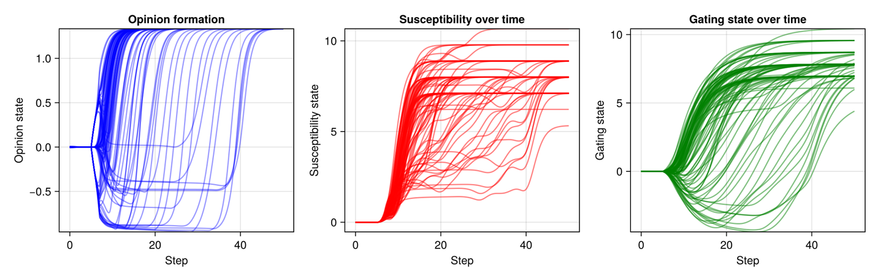

**WITH GATING –– homogeneous damping –– I = 0.4 (high) –– WS4 –– seed2854**

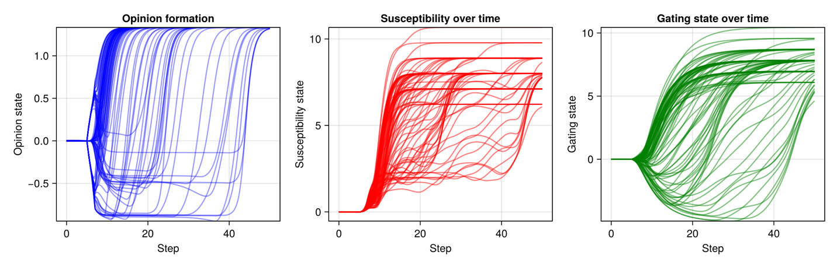

**WS4 – seed 9286 – longer**

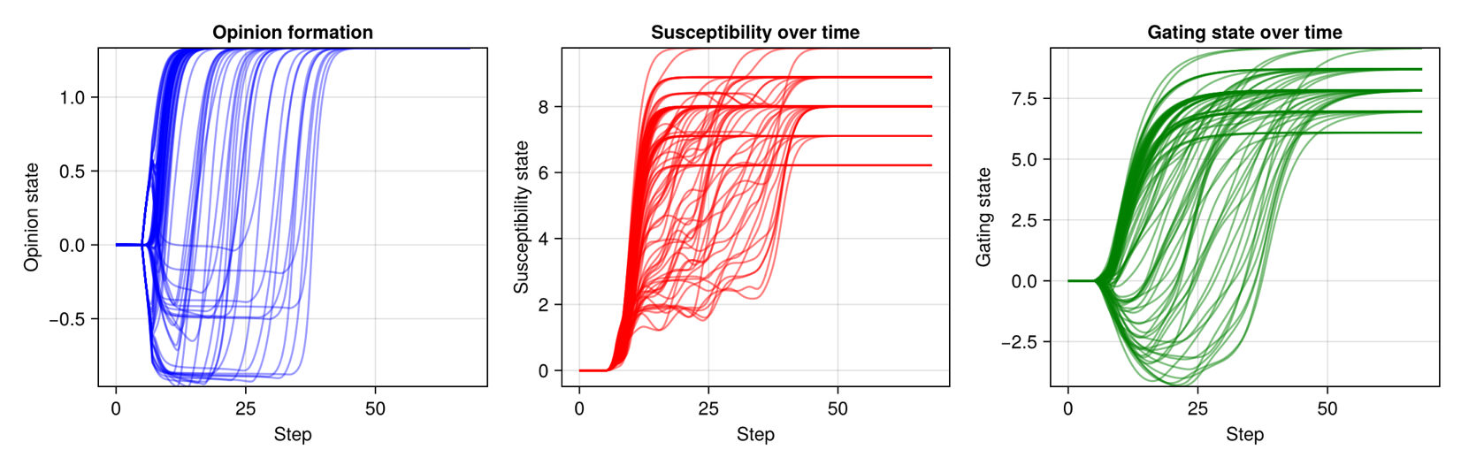

**WITH GATING –– homogeneous damping –– I = 0.4 (high) –– WS5 –– seed2854**

